COLAB 2: Connecting Github to Google Colab

To connect Github to Google Colab, you need to do the following steps.
- Follow the instructions to create a Github account available on Canvas and fork the lectures, but skip the instructions related to downloading “Github Desktop”. We will do this in Google Drive instead.

- Create a personal access token: This gives third-party websites (like Google Drive), access to your Github files.

- Upload the following file to Google Drive.
“COLAB 4_importGITHUB_RunOnce.ipynb”
“COLAB 5_syncGITHUB_RunFrequently.ipynb”
- They don’t have to be in any specific location, but make sure to keep them somewhere handy (you will need them again).
- These files substitute the role of Github Desktop: they will allow you to manually synchronize Drive with Github.

- Open these files in Google Colab and follow the instructions. You will have to enter the Personal Token you obtained from Github.

- As the title suggests, the “import” file copies a repository from your Github account to Google Drive. Bear in mind that this will NOT automatically synchronize. Think of it more as a one-time download.

- The “sync” file tells you how to sync with the cloud, and to check for updates to the Lecture Notes. You need to run this every time you want to sync.
  - This makes “Github” different from other cloud storage services and it’s done that way be design.
  - Programmers typically sync their work with colleagues or team members once they’re ready to share what they’ve been doing.

Appendix: Creating a Personal Access Token

- Sign-in to “github.com”. Click on the top-right corner with your profile picture.
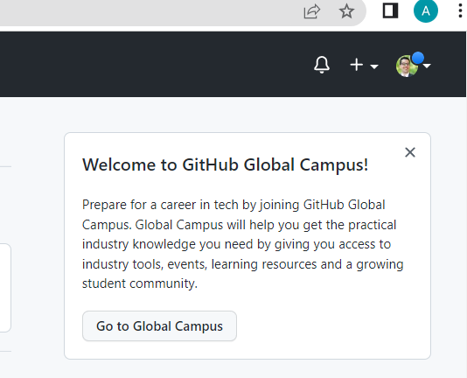
- In the drop-down menu select “Settings”
- Scroll down and search for an option called “Developer settings”. You might see this in the panel on the left.
- Go to personal access-tokens and click on the option “Tokens (classic)”.
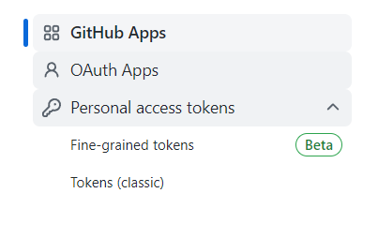
- Click on the option “Generate new token” and select the (classic) option.
- You should see a menu like this:
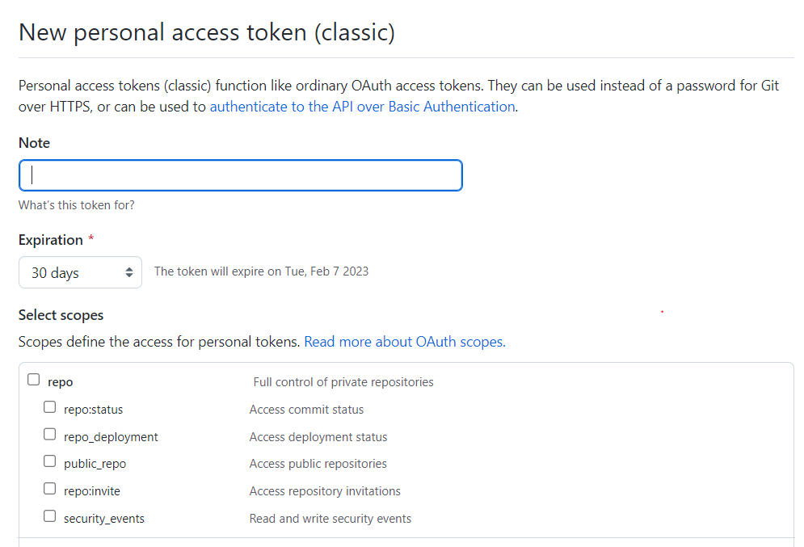

- Add any name that you like
- Be careful to set the expiration date. By default it’s only 30 days but that would be too short for our course.
  - I would set it for six months or “without expiration”.
  - If you set it for a shorter time, don’t worry. If it expires, just generate a new one. In the other instructions we explain how to work with a new token.
  - Remember to never share your Github token with other people, since this is the access to your account information. Only you will have access to the token and any websites you give permission to it.
- Select the following Scopes (these are the permissions). Basically, we’re choosing permissions to read and write. This is important to synchronize the data with Google Drive.

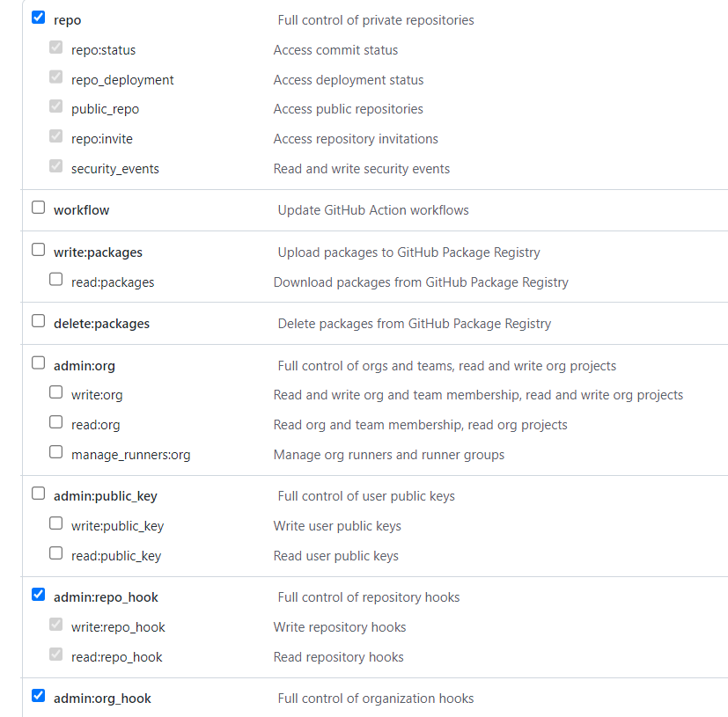

- Generate the token and write it down in a safe location.

